**Practical No. 2**

***Aim (Practical Outcome):-***

|  |
| --- |
| Write a program to draw following graphics objects using built in “C” functions.  Ellipse, Rectangle, Triangle, Polygon |

***Relevant Course Outcome(s):-***

Identify the file structure of display graphics file formats.

***Resources Required (Hardware & Softwares):-***

1. A Desktop PC/ Laptop
2. Ansi C/ Turbo C/ (Any distribution) installed

***Theoretical Background:-***

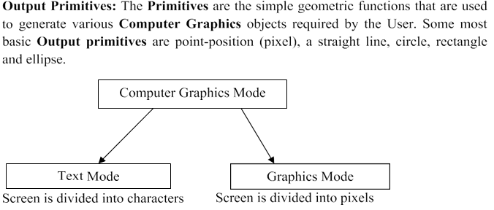

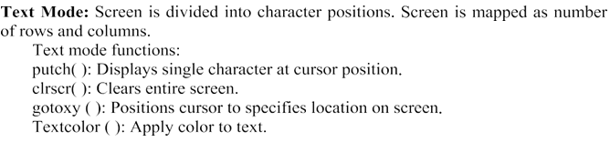

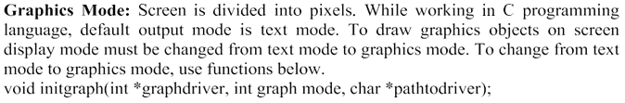

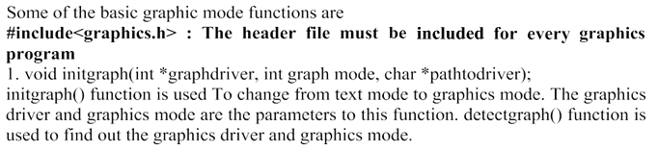

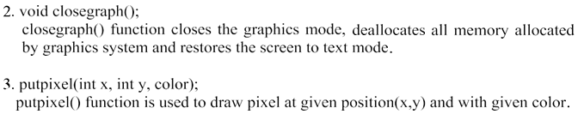

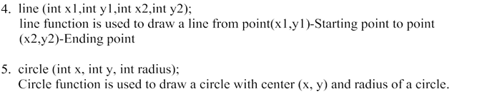

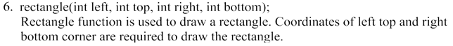

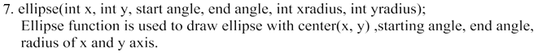



***Algorithm/ Steps to be performed:-***

1. List different basic graphics functions.
2. Select the proper function to draw respective object.
3. Use proper syntax for selected function.
4. Check the required format of output.

***Program*:**

#include <graphics.h>

#include <conio.h>

int main() {

int gd = DETECT, gm;

initgraph(&gd, &gm, "");

ellipse(250, 200, 0, 360, 100, 50);

rectangle(100, 100, 200, 200);

line(300, 100, 350, 200);

line(350, 200, 250, 200);

line(250, 200, 300, 100);

int points[] = {400, 100, 450, 150, 425, 200, 375, 200, 350, 150, 400, 100};

drawpoly(6, points);

getch();

closegraph();

return 0;

}

**Output : - ( Paste your own Output )**

***Conclusion:-***

|  |
| --- |
| Thus, we have executed a program to draw following graphics objects using built in “C” functions.  Ellipse, Rectangle, Triangle, Polygon |